**Report Purpose**: In our recent analysis, we found significant findings in regards to company site and established three Key Performance Indicators (KPIs)**conversion rate**, **social media,** and **customer reviews**. This report demonstrates the data found in each of the bold above sections and gives a detailed description of our analysis.

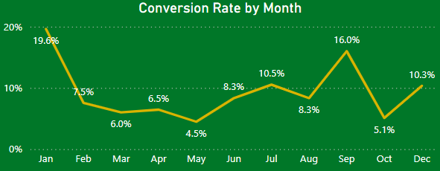**Conversion Rate**: Throughout the year our conversion rates varied. At the start of the year we had a 19.6% conversion rate that dipped to a low of 4.5% in May, had a strong rebound in September at 16% and after a dip to 5.1% in October, conversion rates climbed back to 10.3%.

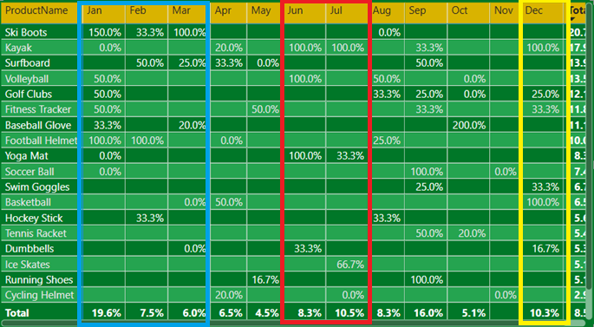Looking at a breakdown of conversion by product, at the start of the year in January, there was a large variety of items with 50% or more conversion rates. This could be attributed to a lot of customers and potential customers participating in fitness as their New Year’s resolutions. Ski boots were the number one converted item for the first quarter with January having the highest conversion rate at 150%. In the summer months of June and July, items like volleyballs and kayaks held the highest conversion rates at 100% likely due to the warmer season. December brought a mix of items being converted during the holiday season.

****Social Media Engagement:** Data analysis reports an overall decline in social media engagement for Shop Easy. Our data shows an overall consistent decrease in user interactions (likes, comments, views) for the year 2024. While views are down this year compared to last, the percentage of clicks to views is still 15.4%, meaning engaged users are still interacting with our content effectively. Looking at our current media types being used in our social media campaign indicates that blogs and engagement social media accounts (X, Facebook, Instagram, etc.) remained consistently engaging through they year while engaging videos were only dominant in January.

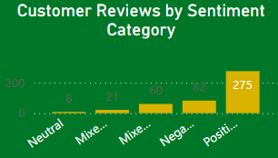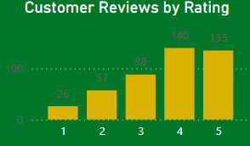**Customer Reviews:** Overall customer reviews were mostly positive with the majority being either a rating of 4 or 5 for the year. Sentimental analysis ran on the comments showed a strong mix of how clients felt about our products, but remained overall mostly positive with 275 reviews trended toward a positive rating. Lower ratings of 1 and 2 were in the minority found in just 82 reviews. Ratings were mostly consistent through the year with a jump in positive reviews between February (16 positive reviews) and April (31 positive reviews).

**Goals and Actions:** Shop Easy has three majors goals to focus on for the next quarter: **increase conversion rates, enhance customer engagement,** and **improve upon over customer feedback**. **Conversion rates** are trending on the rise for December and will likely remain higher trending in January. A strong recommendation of targeting high converting items such as *ski boots* and *general fitness items*in the first quarter as they showed the highest rates of conversion in 2024. Marketing campaigns should target appropriate seasonal items such as with *kayaks* and *volleyballs* during the summer months.

**Social media has had a strong decline** and recommended actions would be to look at revitalizing content. Blogs and general social media posts did well but experimentation with interactive videos could further engage clients and boost views. Consider looking at trending platforms such as *Tiktok* and *Instagram Reels* and create interactive videos to get users commenting and those turn into website views.

**Customer reviews** have been overall mostly positive at an average of 3.67 for 2024. A strong recommendation to further boost a positive review score would be to look at those who left negative reviews and investigate why clients left them. Addressing negative concerns for those who left mixed reviews and negative reviews should be the priority. Actions to resolve could be to develop a plan to resolve negative concerns and to follow-up with clients who left mixed and negative reviews. Addressing clients concerns and allowing the opportunity to re-rate products after resolution could bring us back to the targeted 4.0 average rating goal.